Primary 4___ Name: ____________________ ( ) Date: _______________

Online Diary Entries

Think about your shopping experiences in Hong Kong and complete your online diary entries below.

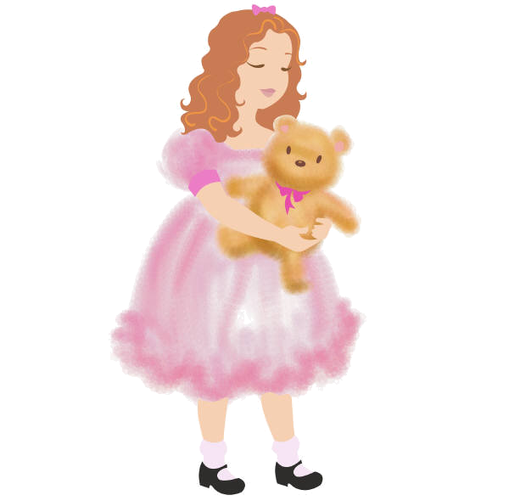
____________________ Online Diary
____________________
I went shopping with ___________ in Sha Tin / Mong Kok / Tsim Sha Tsui this morning / afternoon / evening. It was ____________________. I spent ____________________ dollars on ______________________________. They were very ______________! I think I’ll ____________________ again!
posted at 10:02 pm

____________________
____________ spent ____________________ shopping with me in _________________________________________ today. There were ______________________________ and ______________________________________. I think they were ____________________!
posted at 8:15 pm

