Primary 3___ Name: ____________________ ( ) Date: _______________
Poster
After the school camp, your school is going to have a photo-taking competition. Now design a poster about it.
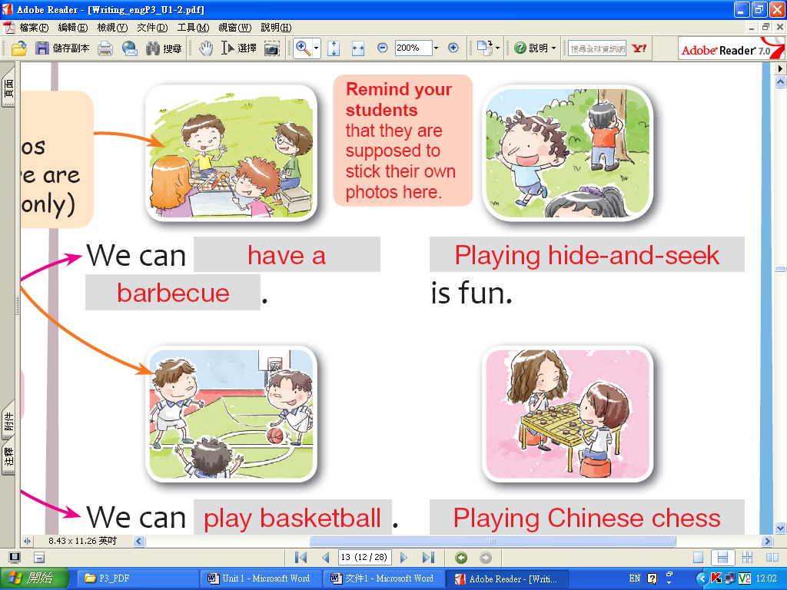
Best ____________________ Photo
Vote Now!
Below are the photos taken by students at the _________________________________. Choose the best one!
Details of the voting activity:
Date: ____________________
Time: ____________________
Place: ____________________

For further information, please contact ________________.
We can _____________________.
We can _____________________.

is fun.
________________________ is our favourite activity.

