Primary 2___ Name: ____________________ ( ) Date: _______________

My Meal
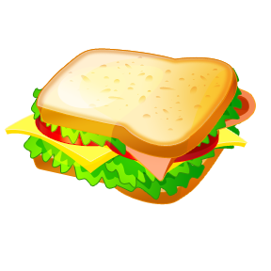
Quick breakfast / lunch / dinner
Red tomatoes / apples / strawberries
Salad / Sandwiches / Soup with _________________
Tasting great / cool / terrible
I ______________________________________________

